**Lab 5: Lights out**

**Daniel Williamson and Brandon Billington**

**Due date: 3-22-16**

**Section 1**

Problem Statement:

The problem for this lab to create a game called lights out, where pressing on the boxes toggles the lights on or off.

Requirements:

* Use try - catch statements.
* Create custom exception classes.
* When a square is pressed, it should toggle the squares to the left, right, bottom and top.
* Have the program read in a file and determine whether the file is or is not valid.

Planning:

The planning done for this class was first creating the three java files that we knew we needed to have. We then began with creating methods that would essentially return nothing to test whether we could actually call the methods correctly from the classes we were given. Once we did this correctly we were able to pull up an empty frame of LightsOut. Once this was complete we began filling the methods giving them commands on what they need to do. We started with creating the games size and toggling just one tile at a time. Once we had the game working properly we worked on reading in a file. To do this we had to created our own custom exception class to catch if their were any invalid characters in the read text file. That was pretty much it for the planning.

Implementing and Testing:

This is a depiction of the game running. After only 2 presses the lights above, below, to the left and right were toggled on.

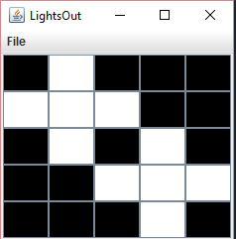

This is a depiction of the game after the file provided to us was scanned in.

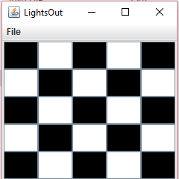

This is the message read out when an invalid file is scanned into the game.

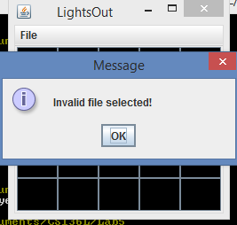

This is a depiction of selecting different sizes for the game board.

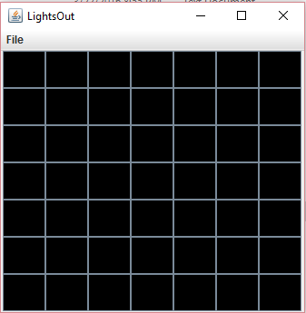

Reflection:

In the end we’re pretty happy with the end result of program. It does everything we want it to do, we thought it was going to be a much more difficult process. Things we could improve upon is our variable names because, some names we chose didn’t exactly make sense for what the code was trying to do. Other than that, we’re pretty satisfied, the code ended up not being as long as we thought it was going to be. This was a very insightful lab into the world of try-catch blocks and creating custom exception classes.